**ASSEMBLY INSTRUCTIONS FOR VILLAGE WATER FILTERS**

**FACILITY FILTER MODEL VFF500 (Pressure Valve Unit)**

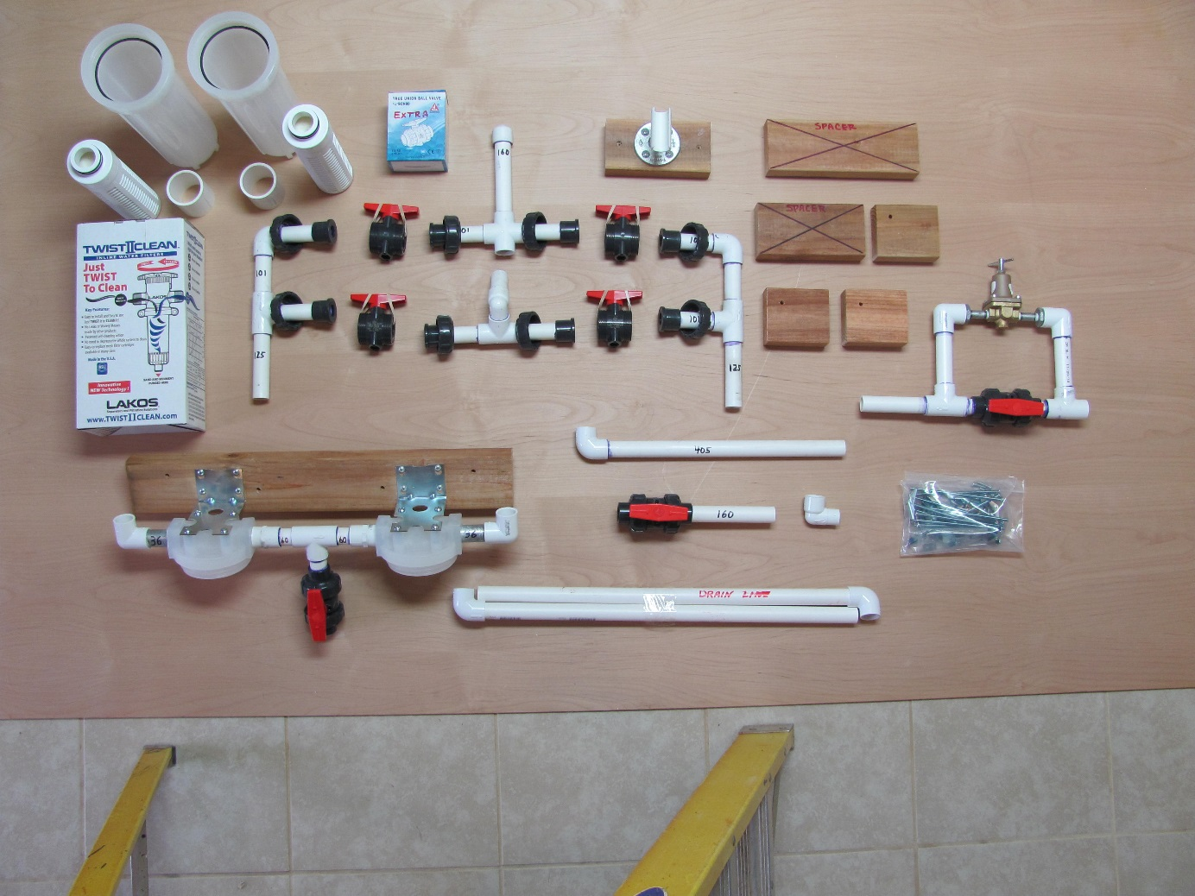

**Remove filter components from the box and become familiar with the parts. Determine if the water supply will enter from the left or the right. If the water enters from the right the Prefilter and Pressure Valve Assembly will be on the right. If the water enters from the left the Prefilter and Pressure Valve Assembly will be on the left.**

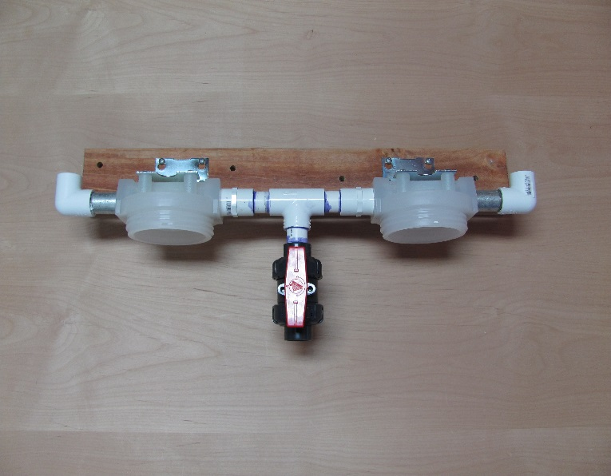**Bolt Filter Mount Assembly to wall with toggle bolts provided. Assembly should be a minimum of 75mm or 30 inches above the floor in order to remove filter housings at a later date. Check to make sure there is room for the remainder of the unit to the left or right of the Filter Mount Assembly.**

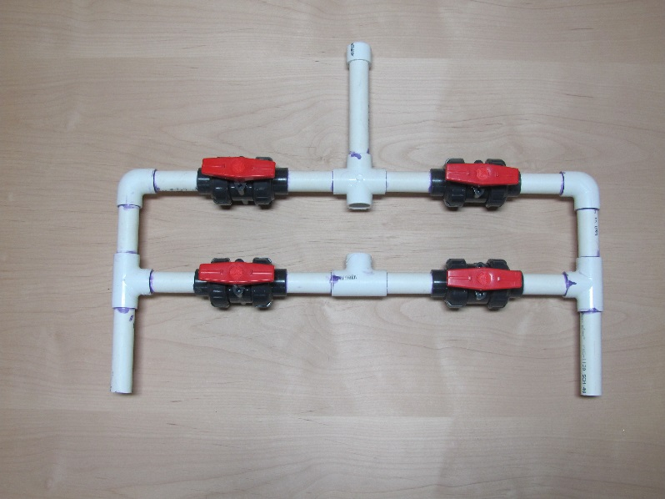

**Assemble the Valve Control Unit together with union ball valves as shown. Make sure all O-rings are in place.**

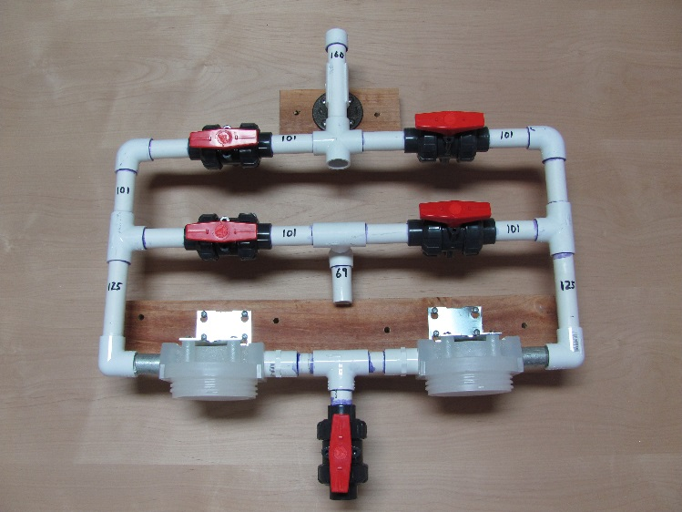

**Cement Valve Control Unit to Filter Mount Assembly as shown. Then bolt the Stabilizer Mount Assembly to the wall and snap in the upper part of the Control Valve Unit.**

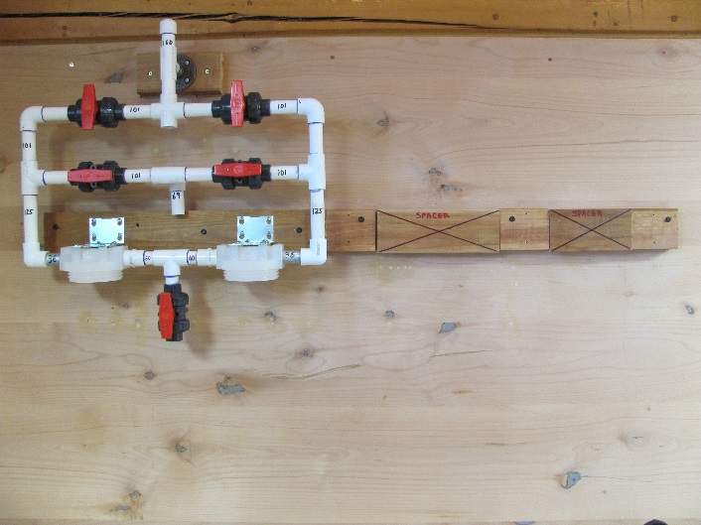

**Wooden supports shown with spacers in place.**

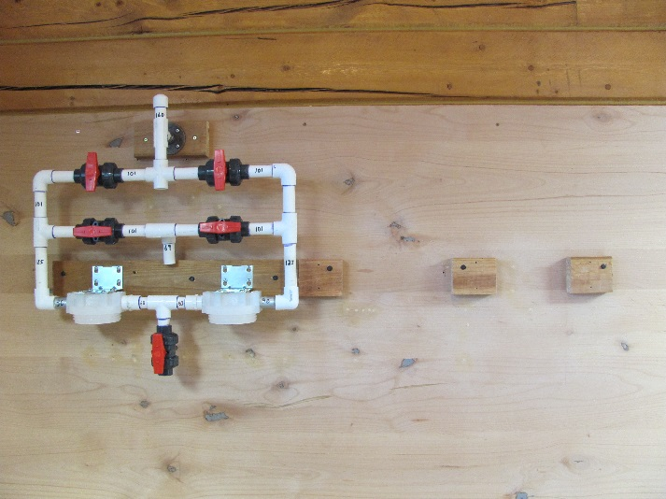

**Bolt wooden supports to the wall with spacers removed.**

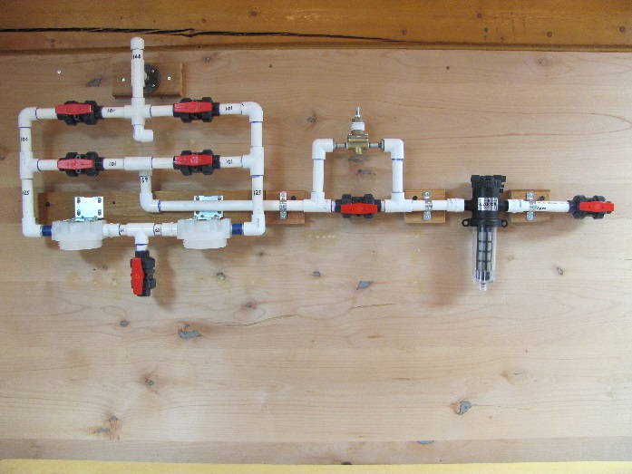**Cement the Pressure Valve Assembly to the Valve Control Unit using the Water Line Connector. Then cement the Prefilter to the Pressure Valve Assembly. Then cement the Supply Line Control to the Prefilter. Place metal straps over the PVC line as needed for support. Use screws provided.**

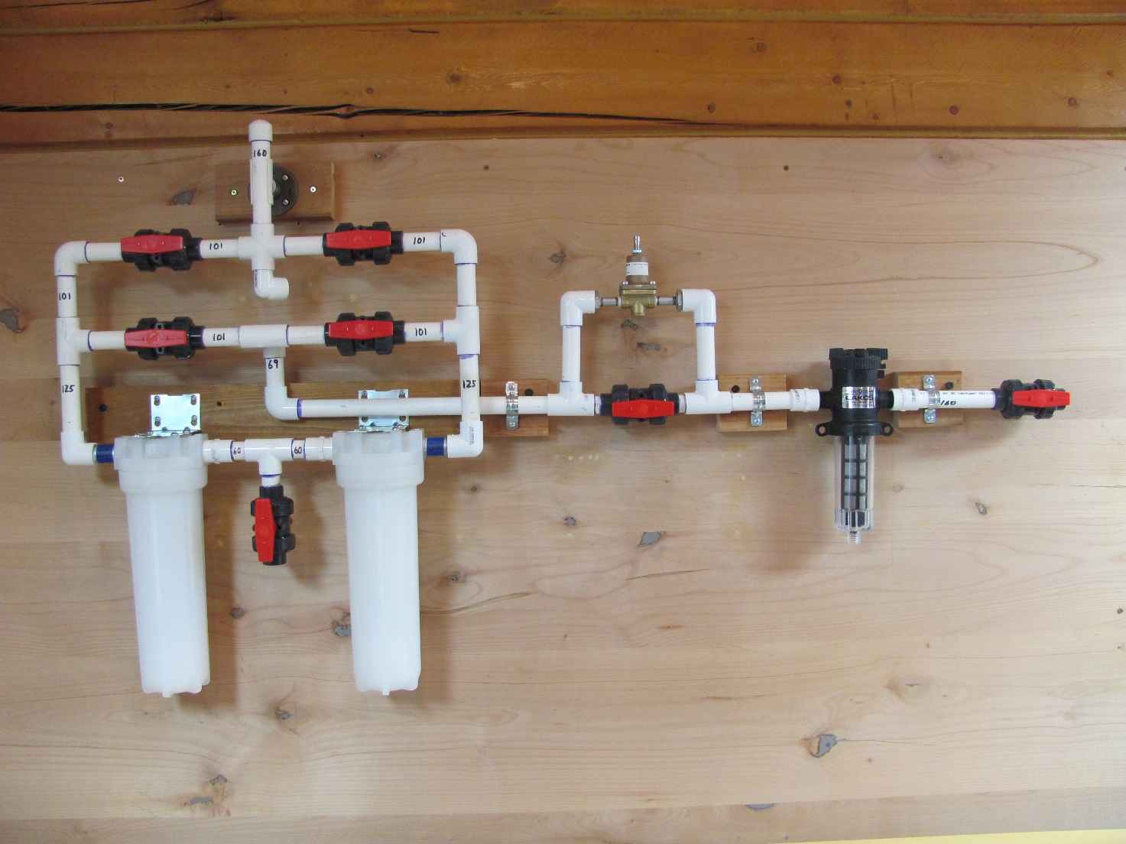

1. **Wet 0-rings on top of the 25mm or 10 inch filters and insert up into Filter Mount Assembly.**
2. **Check that each Housing has a large O-ring in place. Place PVC spacer into Housings and screw Housings into Filter Mount Assembly.**
3. **When back flushing the filters, dirty water will come out of the 4-way fitting in the Valve Control Unit. This water should be discharged into the sewer or onto the ground. The Back Flush Drain Connector, two pieces of PVC pipe and two elbows are provided to assist with this connection.**
4. **You are now ready to use your VFF 500 water filter. Back flushing instructions are included separately.**