**BACKFLUSH INSTRUCTIONS**

**FACILITY FILTER MODEL VFF 500**

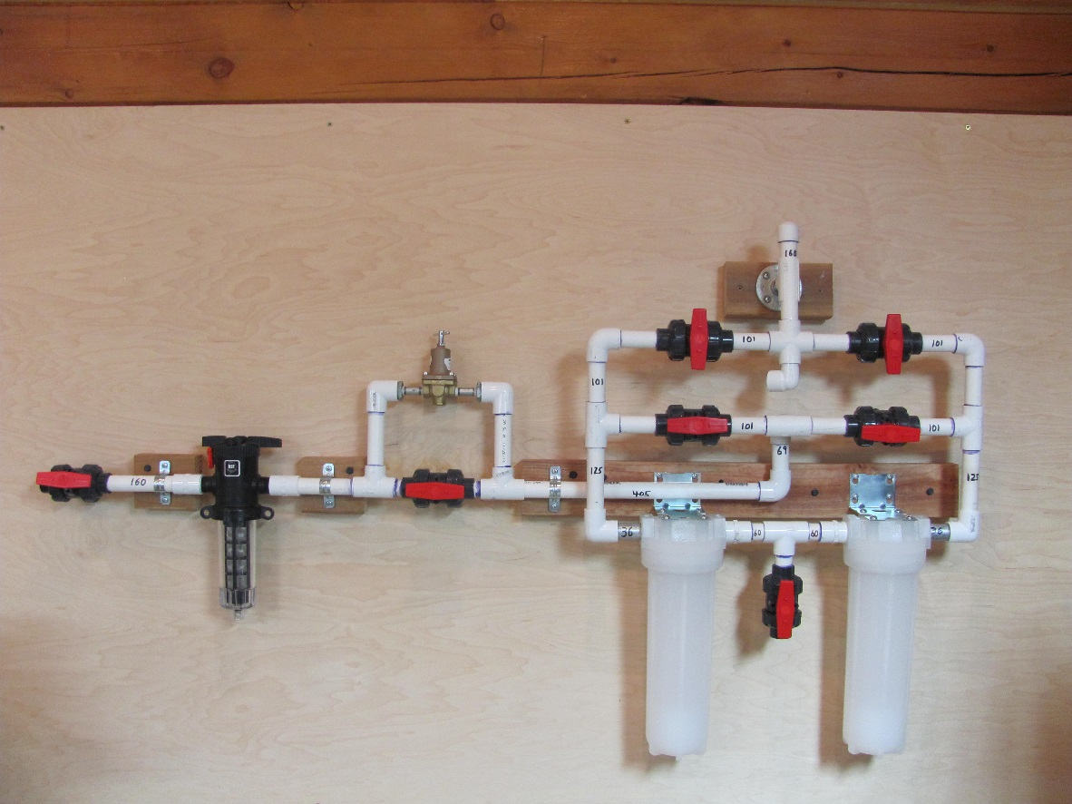

**NORMAL OPERATING POSITION**

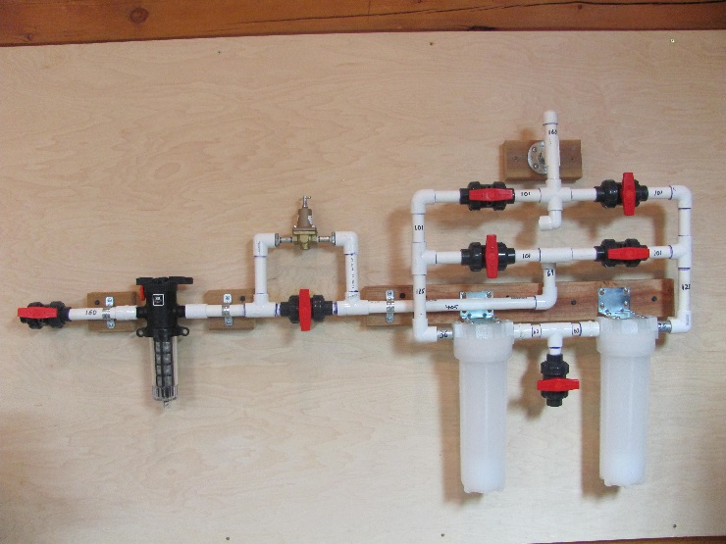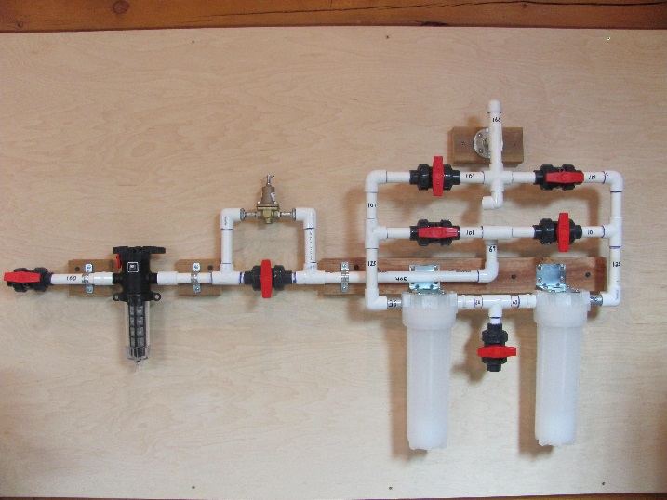

**BACKFLUSH LEFT FILTER POSITION BACKFLUSH RIGHT FILTER POSITION**

**BACKFLUSH BOTH FILTERS DAILY UNTIL WATER RUNS CLEAR**